Agroforestry
Newsletter

National Research Centre For Agroforestry, Jhansi-284 003

Vol.18, No. (1) January- March, 2006

FROM THE DIRECTOR’S DESK

COLD WAVE OF 2005 – 2006 EFFECT IN RAJASTHAN: IMPACT ON AGRICULTURE
The climate of the Zone IIa (Transitional Plain of Inland drainage) comprising districts of Sikar, Jhunjhunu, Nagour and parts of Churu range from arid to semi-arid with an average rainfall of 300 – 500 mm, which is mainly received in the months of July and August. The temperature goes as high as 50 ⁰ C in summers and as low as – 2.5 ⁰C in winters. However, this year the area experienced very low temperatures due to cold wave during 25th December, 2005 to January 10th 2006 when minimum temperature remained below 0 ⁰C for six days continuously and dipped to – 5.5 ⁰C on 8th January 2000. This affected crops as well as fruit plants and other trees. A preliminary survey conducted by the AICARPAF Centre RAU, Fatehpur Shekawati team in Sikar district indicated devastation caused by the cold wave. Most of the tree and plants were affected except Prosopis cineraria (Khejri) and Tecomella undulata. However, there was a positive affect on wheat as it enhanced tillar formation. The survey will be conducted again to monitor the after effects.
Cold wave effect in Fatehpur Shekhawati, Rajasthan (Sikar District)- A preliminary survey (25.12.05 to 10.01.06)
Severely Damaged  >75 %, all age groups affected) | Partially damaged  (25 % young plants upto age of 3-4 yrs affected) | Not Damaged  (less than 5 %)

Trees
Prosopis juliflora | Hardwickia binata | Prosopis cineria
Acacia tortilis | Acacia nilotica | Tecomella undulata
Moringa oleifera | Caparis aphylla | Acacia senegal
Azadirachta indica | Dalbergia sissoo | Salvadora olievra
Cordia myxa |  | Prosopis specigera (Roong)
Ailanthus excelsa
Ficus religiosa
Albizia lebbeck
Melia Azadirachta

Fruit Trees
Aonla | Mango | Citrus species
Guava |  | Bael
Karunda
Zizyphus mauritiana
Shrubs
Jatropha | Leptadinia pyrotechnica | Crotolaria bhuria
Calotropis procera | Tephrosia purpuria | Kochia viscosa
Mopen

Crops
Mustard ( early sown crop (October) more damaged compared to late sown crop (November) | Methi, Gram, Jeera | Wheat, barley (+ve effect on tiller formation which compensated for damage in mustard crop)

THREE DAY TRAINING PROGRAMME ON TREE MENSURATION AND MODELING IN AGROFORESTRY (8 to 10th FEBRUARY, 2006)

The All India Coordinated Research Project on Agroforestry is in existence since 1983, during this period it has contributed significantly towards popularizing location specific agroforestry practices and increasing the tree cover outside the forest area. Agroforestry being a multidisciplinary land use, the research scientists involved in the project belongs to various disciplines with different backgrounds. In this context, during the last Annual Group Meeting of the AICRP on Agroforestry held at CSSRI, Karnal (20 – 22 August, 2005), it was felt that there is a need to practically train the scientists associated with the project in the field of tree mensuration and modeling. The Annual Group Meeting came out with a recommendation that National Research Centre should conduct training for Agroforestry for the researchers associated with the project. Accordingly, a three days training programme on tree mensuration and modeling in agroforestry was held during February 8th – 10th, 2006. The objective of the training was to have uniform methodologies and procedures for conducting trials and taking observations at all the coordinating centres of the project. The training was attended by one scientist from each coordinating centre of the project. The training programme mainly focused on practical classes related to tree growth parameters, biomass estimation, development of volume equations and simulation modeling. The participants from different coordinating centres provided the tree growth data for developing volume equations and simulation models. The participants were also given practical training in the use of tree mensuration instruments like Ravi multimeter and Spiegel Relaskop. The resource persons were Dr. R.S. Dhanda, Retired Prof. PAU, Ludhiana and Dr. N.K. Gupta, Silviculturist, YSPUH&F, Solan besides the scientists of the NRCAF. The programmes was great success and fulfilled the long pending need of the project.

KISAN GOSHTI
The Centre organised Kisan Goshti at Village Garh Kundar and Dawar, District Tikamgarh (M P) on 10th March, 2006. Dr. S. K. Dhyani, Director chaired the Goshti and Sh. C.S. Shukla, SDM, Niwari, was the special guest on the occasion. More than 300 farmers from Garh Kundar, Dawar, Sakoli and Shivrampur villages participated in the Gosthi. Scientist of IGFRI, KVK, Bharari and NRCAF were the speakers during the Kisan Gosthi. Improved agroforestry practices were depicted and demonstrated to the farmers through photographs, charts and live materials. Farmers showed keen interest in agroforestry practices and desired to adopt them. Dr. R. P. Dwivedi, Sr. Scientist convened the function.

TRAINING PROGRAMMES FOR JFM COMMITTEE MEMBERS FROM MADHYA PRADESH

The Centre organized two Training Programmes (21st to 23rd March 2006 and 27th to 29th March, 2006) for the office bearers and members/ farmers of JFM committees and officials of M.P. Forest Department of Raisen, Chhatarupur and Chhindwara districts of Madhya Pradesh. Total 67 participants were trained. The programme was sponsored by M P State Forest Department. Participants visited to JFM sites at Lalitpur, Research Farm of the Centre and IGFRI, as part of the programme. These committees are involved in developing options for revenue generation, enhancing biomass productivity and improving health of forest flora in these districts.

NEW PROGRAMMES INITIATED
- Watershed development Project started at Garh-Kundar-Dawar. Watershed committee has been constituted and registered with LEO, Niwari, Tikamgarh (M.P.). Vegetation survey, soil survey and PRA exercises completed. Proposal for construction of one check dam is obtained from society and being processed.
- Bench grafting in aonla (2000 Nos) has been done in the shade house NRCAF. Seedlings of MPTS (Subabool-1000, Nutan (Dichrostechys cineraria) -1000, Jatropha –9000, Kumat (Acacia senegal) -500, Aonla- 1500) are being raised.

NEW AREA DEVELOPED FOR EXPERIMENTATION AT NRCAF
The Centre was facing acute scarcity of area for laying experiments at the farm. Therefore, A rocky degraded boldery land lying unutilized was excavated through JCB and dozer and developed into fields of about one ha. each at the Research Farm. A total of 7 ha have been developed for agroforestry plantations/ Experiment.

HUMAN RESOURCE DEVELOPMENT
- Dr. R. K. Tewari, Sr. Scientist participated in Training Programme on “ IPR and WTO Related Issues” sponsored by DST held at ASCI, Hydrabad (A.P.) during 23rd to 27th January, 2006.
- Dr. P. Rai, Dr. V. K. Gupta, Pr. Scientists and Dr. S P Ahlawat, Sr. Scientist participated in the National Seminar on “Recent Advances in Forest Sciences” at Department of Forestry, Wild life and Environmental Science, Guru Ghasidas University, Bilaspur (Chhattisgarh) during 30th –31stJanuary, 2006.
- Dr. Ajit, Sr. Scientist participated as a resource person in the Workshop on “Modelling” held at Department of Mathematics and Computer Applications at Bundelkhand University, Jhansi (U.P.) during 27th - 29th January, 2006 and delivered lecture.
- Dr. Chitra Shanker, Scientist (Sr. Scale) participated in the International Conference on “Biodiversity of Insects: Challenging issues in Management and Conservation” at Bharathiar University, Coimbatore during 30th January to 3rd February, 2006 and presented two papers.
- Dr. R P Dwivedi, Sr. Scientist participated in the International Conference on “ Social Science Perspectives on Agricultural Research and Development” at IARI, New Delhi during 15th – 18th February, 2006.
- Dr. K. Kareemulla and Dr. R P Dwivedi, Sr. Scientists participated in the 24th National Workshop on “Planning Management of Agricultural Extension Training” organized by Directorate of Extension Education at New Delhi during 14th – 15th February, 2006.
- Sh. C. K. Bajpai, Tech. Officer (T-6) attended Training Programme on “Effective Technical Assistance in Management of Agricultural Research” at NAARM, Hydrabad (A.P.) during 24th –30th March, 2006.

AWARDS
- Sh. Attar Singh, SSG IV, got 2nd prize in Inter Institutional Zonal Meet (Western Zone) at CAZRI, Jodhpur (Raj.) from 1st to 5th February,2006.

NRCAF got awarded for display of aonla verities in the Regional Phal, Shak Bhaji Avam Phool Pratiogita organized by the State Government Horticulture Department, Jhansi from 26th –28th February, 2006.

FELICITATION OF DR. P S PATHAK, DIRECTOR, IGFRI, JHANSI & EX. ADG (AF), ICAR, NEW DELHI

A felicitation programme on 26th January, 2006 was organized by the Director and staff members of the NRCAF, Jhansi to commemorate his retirement as Director, Indian Grassland and Fodder Research Institute, Jhansi and Ex. ADG (AF), ICAR, New Delhi due on 31st January, 2006.

VISITOR
- Dr. G. Kaloo, DDG (Crop Science), ICAR, New Delhi.
- Dr. C. R. Hazra, Vice Chancellor, IGAU, Raipur (Chattisgarh).
- Dr. P.S. Pathak Ex Director (IGFRI), Lucknow (U.P.)
- Sh. Iqbal Singh, Chief Conservator of Forest, Jhansi (U. P.).
- Sh. Rajiv Garg, Conservator of Forest, Jhansi (U. P.).
- Dr. K. A. Singh, Director, IGFRI, Jhansi (U. P.).
- Dr. A. K. Bisaria, Conservator of Forest, Bhopal (M. P.).
- Sh. Sanjay Gupta, Executive Engg. CPWD, Indore (M. P.).
- Dr. R.S. Dhanda, Retd. Prof. PAU, Ludhiana (Panj.)
- Dr. N.K. Gupta, Silviculturist, YSPUH&F, Solan (H.P).
- A delegation of 16 Members from Bhutan.
- Officer Trainees from CSWCRTI, Research Centre, Kota (Rajasthan).

NEW SCIENTIST
Dr. D. R. Palsania, Scientist (Soil Science) joined the Centre on 22nd January, 2006

DIRECTOR’S VISITS:

AICRPAF Centre at Fatehpur Shekahwati during January 16-19, 2006.
- ICRAF meeting at WAC, New Delhi during February 15-16, 2006.
- Director’s Meeting of NRM Division at KAB-II (ICAR), New Delhi on March 20, 2006
- Chief Guest: Inaugurating Student Councilling Centre, IACEE& FO, Bundelkhand
University, Jhansi on February 22, 2006.
- Special Guest: Training on Forage crop, DUS Testing at IGFRI, Jhansi, March 4th, 2006

INFRASTRUCTURE DEVELOPMENT & REVNUE GENERATION AT NRCAF:

With the pro active role by the various section of the NRCAF New equipments worth Rs. 29.51 lakhs purchased, works such as Farm development, new construction of mist chamber etc. costing Rs. 42 lakhs were completed. The Centre generated more than 12 lakhs revenue through sale of farm produce, HRD or other training

SERVICES AVALABLE AT THE CENTRE

NRCAF offers consultancy to Farmers, Government Departments, Cooperatives, Private Sectors and other interested organizations on
- Selection of tree species, tree crop combinations of Agroforestry
- Selection of trees for rehabilitation of degraded lands
- Establishment of nursery, propagation techniques of tree species
- Preparation of development project reports, on line search and access of information on tree species suitable for agroforestry
- Insect-pest management in agroforestry
- Biotechnologies (Tissue culture)
- Soil fertility evaluation
- Agroforestry based land use plan
Centre also conducts training programmes for officers of various Government departments and other organizations on different aspects of agroforestry.
Centre caters the need for improved seedlings of Aonla, Jatropha, Karanj, Neem, etc. to a limited scale.

Critical Analysis of Research on Mahua in Indian context
Ajit, Lokesh Bharsakle, Nighat Jabeen and A.K.Handa
National Research Centre for Agroforestry (NRCAF) Jhansi-India

India is the second most populous country of the world and meeting its energy requirements in a sustainable manner continues to be a major challenge. India produces only about 30% of its annual crude oil requirement of 105 MT, relying on imports to the tune of Rs. 90,000 crores for meeting the remaining requirement. Needless to say, the oil import bill has serious consequences for the Indian economy. In this scenario, giving biofuels a serious consideration as potential energy sources of the future is the most logical step. According to Report of National Mission on Decentralized Biomass Energy for Villages and Industries-2006, there are about 423 oil yielding species such as Madhuca longifolia/latifolia (mahua), Jatropha curcas (ratanjot), Shorea robusta (sal), Scheichera sp, etc. Planning Commission of India, in its Report on Biofuels-2002 gave emphasis on non traditional seed oils (Madhuca longifolia, Shorea robusta, Pongamia pinnata, Jatropha curcas, Salvadora and Mesua ferra) available in the country which can be alternatively exploited and attempts are being made for using these non–edible and under exploited oils for production of esters. Our country provides favorable climatic conditions to harbour a vast resource of non-edible or wild-seed crops. From the seeds of these species oil can be derived and developed as biodiesel depending on site-specific requirements. As the use of biodiesel in conventional diesel engines results in substantial reduction of unburnt hydrocarbons, carbon monoxide and particulate matter and is considered as clean fuel since it has almost no sulphur, no aromatics and has about 10% built in oxygen which helps it to burn fully. Its higher octane number improves the ignition quality even when blended with the petroleum diesel.

Madhuca latifolia belonging to Family Sapotaceae, is a large, much branched deciduous tree attaining up to 18 m height. Mahua is common in deciduous forests and dry Sal forests and is usually found scattered in pastures and cultivated fields in central India. The sweet, fleshy corolla of its flowers is eaten fresh or dried, powdered and cooked with flour. The fruit contains valuable oil that is sometimes used for cooking by the tribals. Outer fruit coat is eaten as a vegetable and the fleshy cotyledons are dried and ground into a meal. Ripe fruits are used for fermenting liquor. Leaves, flowers and fruits are lopped for goats and sheep. Seed cake is also fed to cattle. The heartwood is reddish brown, strong, hard and durable; very heavy (929 kg/cu. m), takes a fine finish. It is used for house construction, naves and felloes of cartwheels, door and window frames. Oil from the fruit kernels principally consists of palmitic and stearic acids and is mainly used for soap and candle making. Mahua oil is used to treat seeds against pest infestation. De-fatted seed kernels contain 26-50 % saponin. Mahua has a large spreading superficial root system that holds soil together. The wide spreading crown provides shade for animals. Mahua is planted on wasteland with hard lateritic soils used for reclamation. Vesicular-Arbuscular Mycorrhizal (VAM) associations and root colonization have been observed in mahua. The seed cake is used as fertilizer. Mahua is occasionally planted as an avenue tree. It is planted along the boundaries of fields for fencing.

Lot of research (Pesticidal properties, Intercropping, Chemical composition, Growth and yield performance etc.) has been carried out in India from early 70’s on Madhuca spp.,. However, this research work is scattered and available in the form of reports, bulletins, newsletter, articles etc. An attempt has been made at NRCAF, Jhansi in this direction to compile all the published research information at one platform in the form of a database, so that it is easily accessable to researchers, planners, policy makers etc.

Synthesis of published information on Madhuca in India (1971-2005):
- Year wise:
- The database covers 294 Indian Madhuca research records in all from 1971 to 2006, with maximum records published in 2002(22) followed by 1991(21) and 1997 (19) records.

- Species wise: Out of the 4 species recorded and researched in India viz, Madhuca latifolia/longifolia, M.butyraceae, M.bourdillonii and M.malabarica, maximum research has been carried out on Madhuca latifolia/longifolia (288 record) followed by M.butyraceae (6).

- Journal wise: The database includes 143 Journals and 3 books. Maximum papers have been published in Indian Forester (24) followed by Indian Journal of Forestry (11), Indian Journal of Nematology and Journal of Tropical Forestry (9) each.

- Author wise: The database conceals 590 Indian authors who have researched on Madhuca.

- Institute wise: The database consists of 144 Indian Institutes/ Universities/ Organizations researching on Madhuca with maximum records from Tamil Nadu Agricultural University, Coimbatore (17), followed by Forest Research Institute, Dehradun (11) and 10 records each from National Research Center for Agroforestry, Jhansi and Banaras Hindu University, Banaras.

- Subject category wise: One of the important finding of the work is that maximum research has been reported on pesticidal properties having 119 records followed by chemical composition consisting of 16 records, growth and yield (15).

- State wise: Maximum research has been reported from the state of Madhya Pradesh (20), Uttar Pradesh (16) followed by Tamilnadu (13).

- Madhuca in agroforestry: The database covers 4 crops viz, Cajanus cajan (Arhar), Cicer arietinum (Chickpeas), Triticum aestivum (wheat), Sorghum vulgare (Jowar) that has been intercropped (agroforestry) with Madhuca longifolia, of which Triticum aestivum and Cicer aeritinum are reported to be the best compatible associates.

Studies were conducted at NRCAF, Jhansi on agrisilviculture systems to study the effect of 12 multipurpose trees including Madhuca latifolia/Madhuca longifolia planted at different spacings on the productivity of different intercropped crops viz., chickpea (Cicer arietinum), wheat (Triticum aestivum), gram (Cicer arietinum), arhar (Cajanus cajan) grown in different crop rotations. Results revealed that maximum grain yield of chickpea and wheat was recorded from the interspaces of Madhuca latifolia and in arhar/gram combination, grain production was observed to be 79% in association with Madhuca latifolia as compared to crop control and tree growth was better in agroforestry than in sole tree plantation.

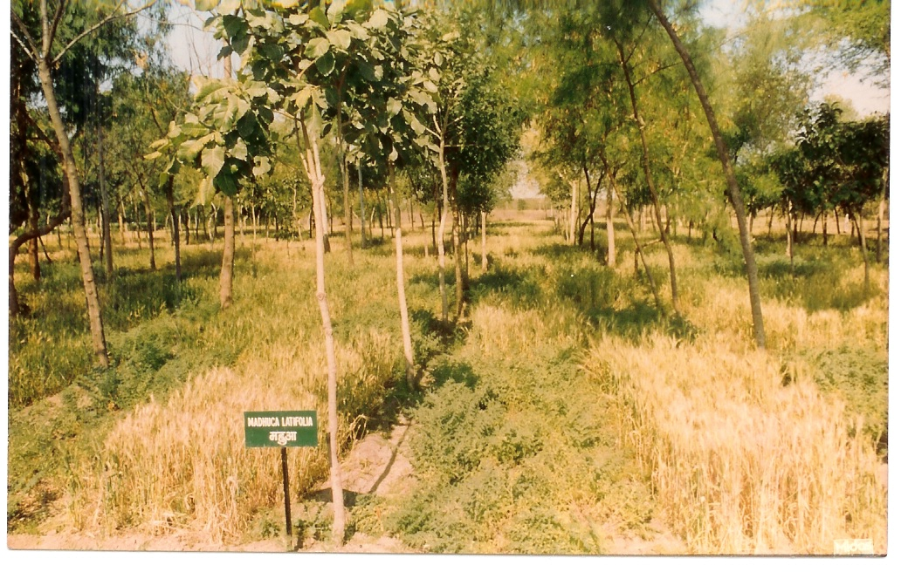
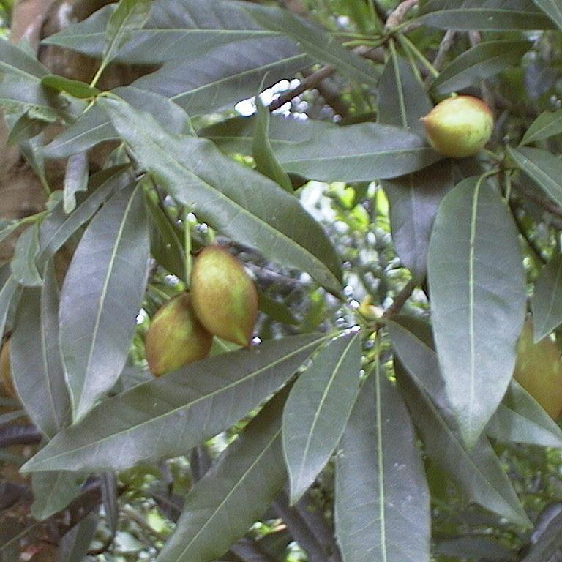
Mahua in fruiting stage
Mahua in agroforestry at NRCAF, Jhansi

